Homework 1

One more puzzle with SMT Solver

21400350 Pang Sun Ki

Description

1. **Constraints:**

I found about 5 constraints need to be stated for this solution.

1. There should be exactly two number per a cell.
   1. K value of Aij and Color value of Bij
2. The initially given numbers from a puzzle input shouldn’t be changed.
3. The values Aij and Bij have only one value each.
4. The value of Ai0 is sum of black cell of row i.
5. The value of ANj is sum of white cell of col j.
6. **Constraints as logical formula:**

I represented a cell as A(i,j,k), B(i,j,c). (“i” is for row, “j” is for column, “k” is for a value inside a cell and “c” is for a color value inside a cell (0 or 1).

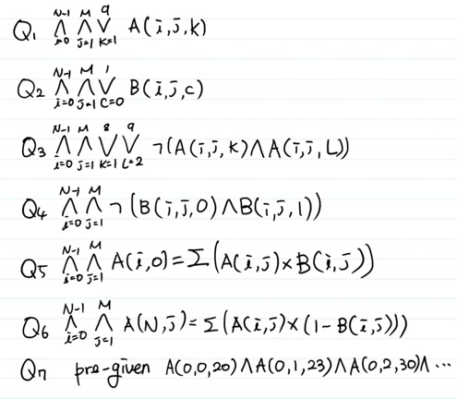

Q1. Aij have a k value (1 to 9).

Q2. Bij have a c value (0 or 1).

Q3. Aij have a just one k value.

Q4. Bij have a just one c value.

Q5. The value of Ai0 is sum of “Aij * Bij” (0< i <N-1, 1 < j < M).

Q6. The value of ANj is sum of “Aij * (1 – Bij)”

(0< i <N-1, 1 < j < M).

Q7. For the pre-assigned cells containing the given numbers from a puzzle, we just use “and” operators to make sure that the pre-assigned cells have fixed values.

1. **Demonstration**

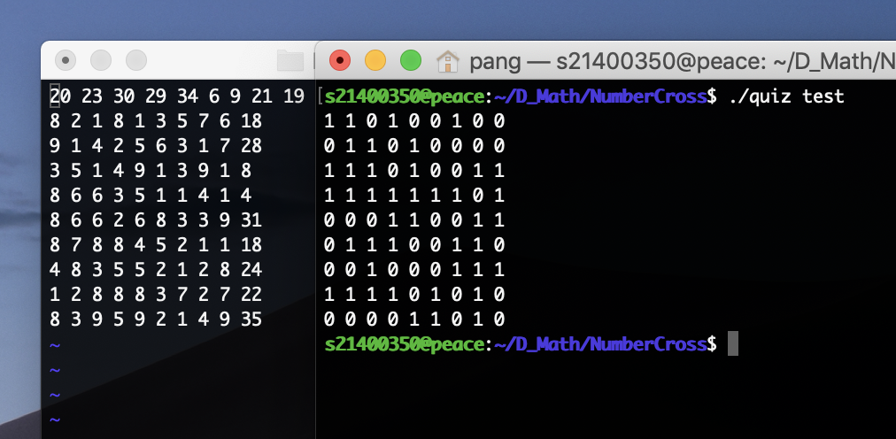 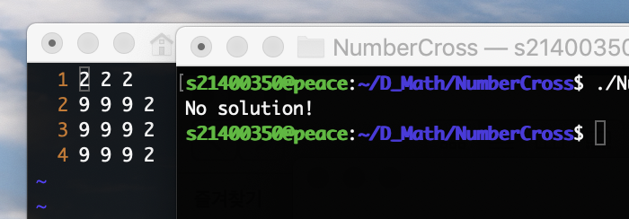

<Test1>: Test case given as an example in ppt. <Test2> Test case that doesn’t have a solution.

Discussion

* In this project, two values were used in one cell, Aij and Bij. This method may be useful in subsequent coding.
* This method will be available when moving many robots on the coordinate, and making cross-patter image.